**IITD Machine Learning-01(chatbot)[INTP23-ML-1]**

**Day 8:**

On day 8, of IITD-AIA FSM internship, I did some EDA and learnt NLP

**Learning:**

Today, I learnt NLP in more depth concepts like word embeddings, word2vec and its two types continuous bag of words and skip-gram. Also learnt the architecture of them and moving further I learnt RNN, in RNN I learnt it’s architecture and types of RNN (one to one, many to one, one to many, many to many) and found out many to many will be used in chatbot. In many to many we used to take multiple inputs and provide multiple outputs. Also learnt forward propagation, backward propagation, the loss function and introduced with the “Vanishing Gradient problem” in which derivative of sigmoid value decreases and become very small that weight updating becomes constant in backward propagation. So, to solve this we use LSTM RNN i.e., long short- term memory recurrent neural network.

After that I learnt LSTM-RNN also; memory cell, forget, input cell.

**Work Done/learning Implemented:**

Basic learning of RNN etc.

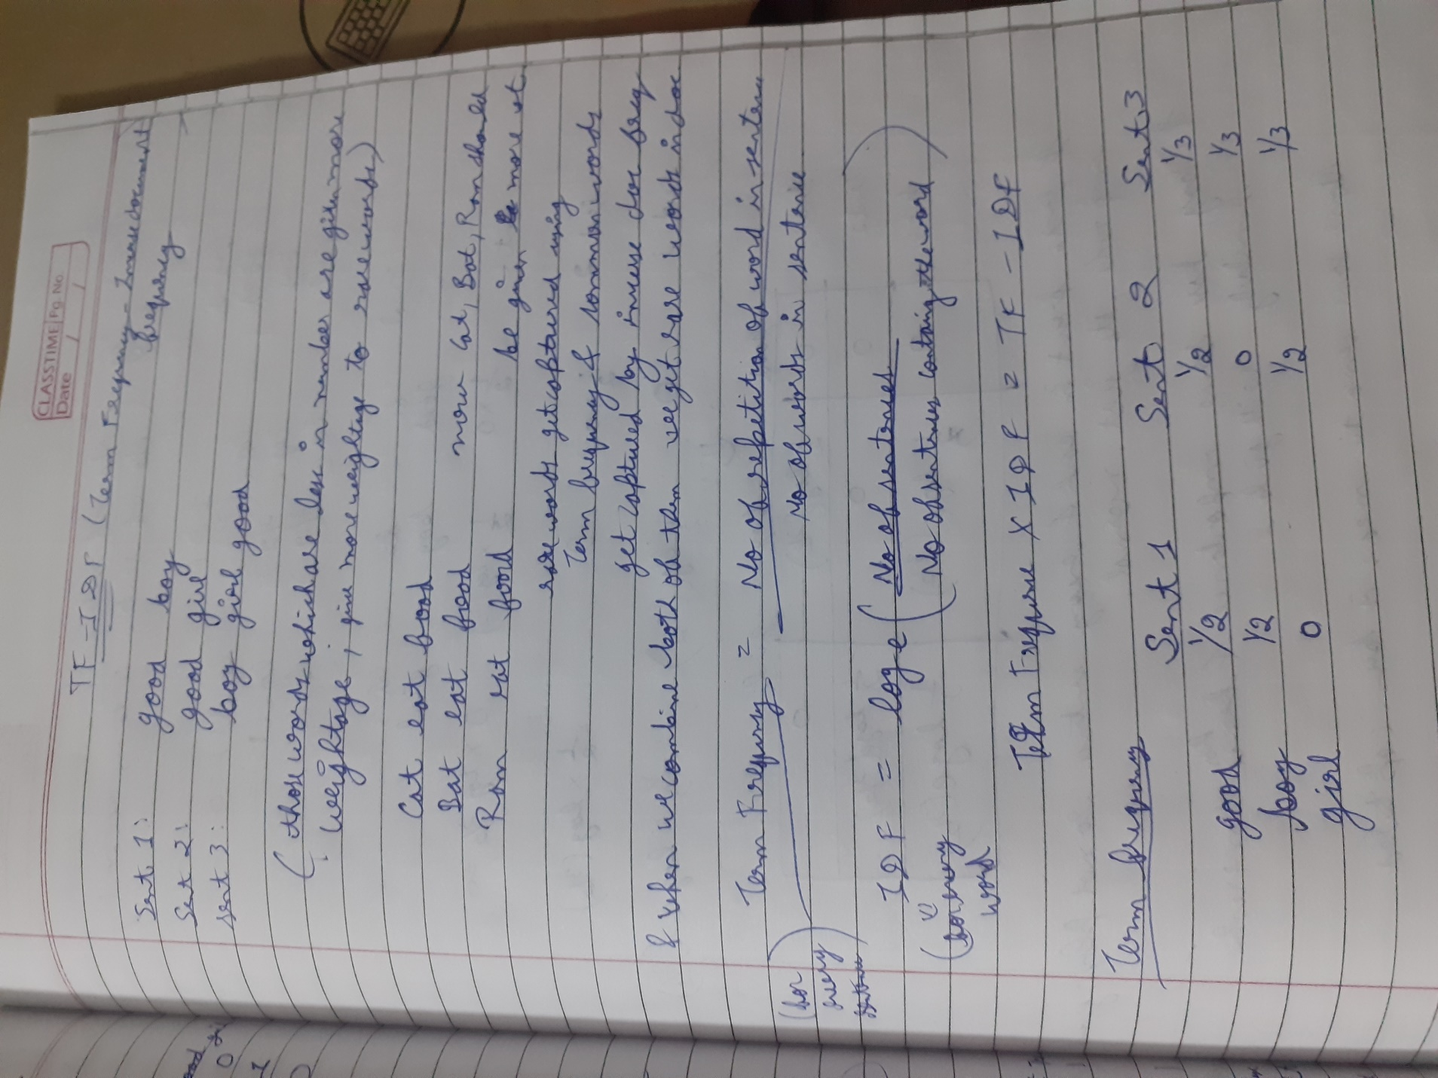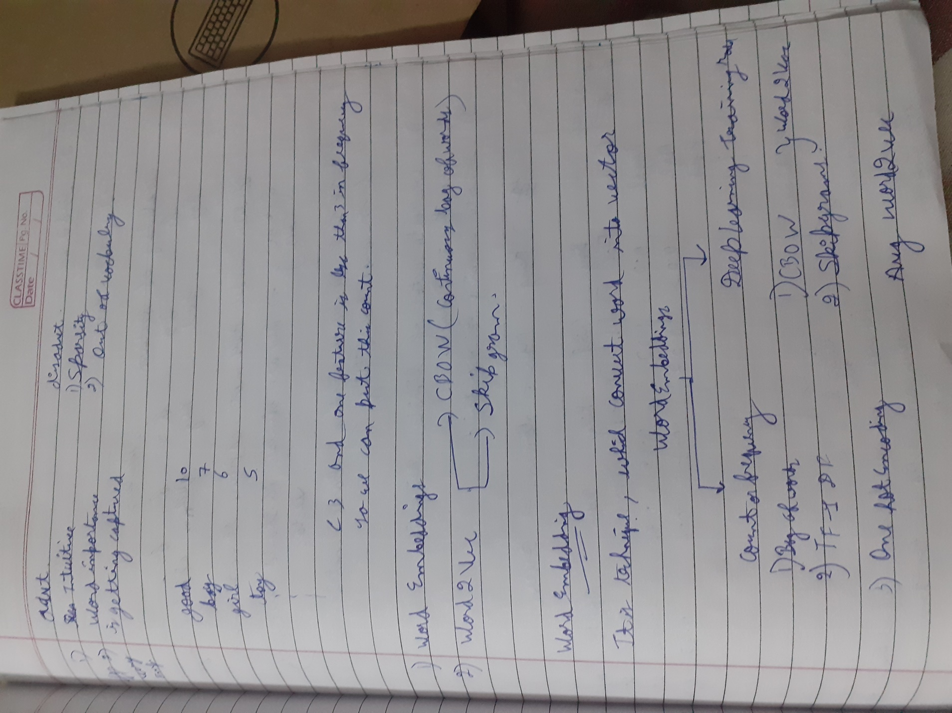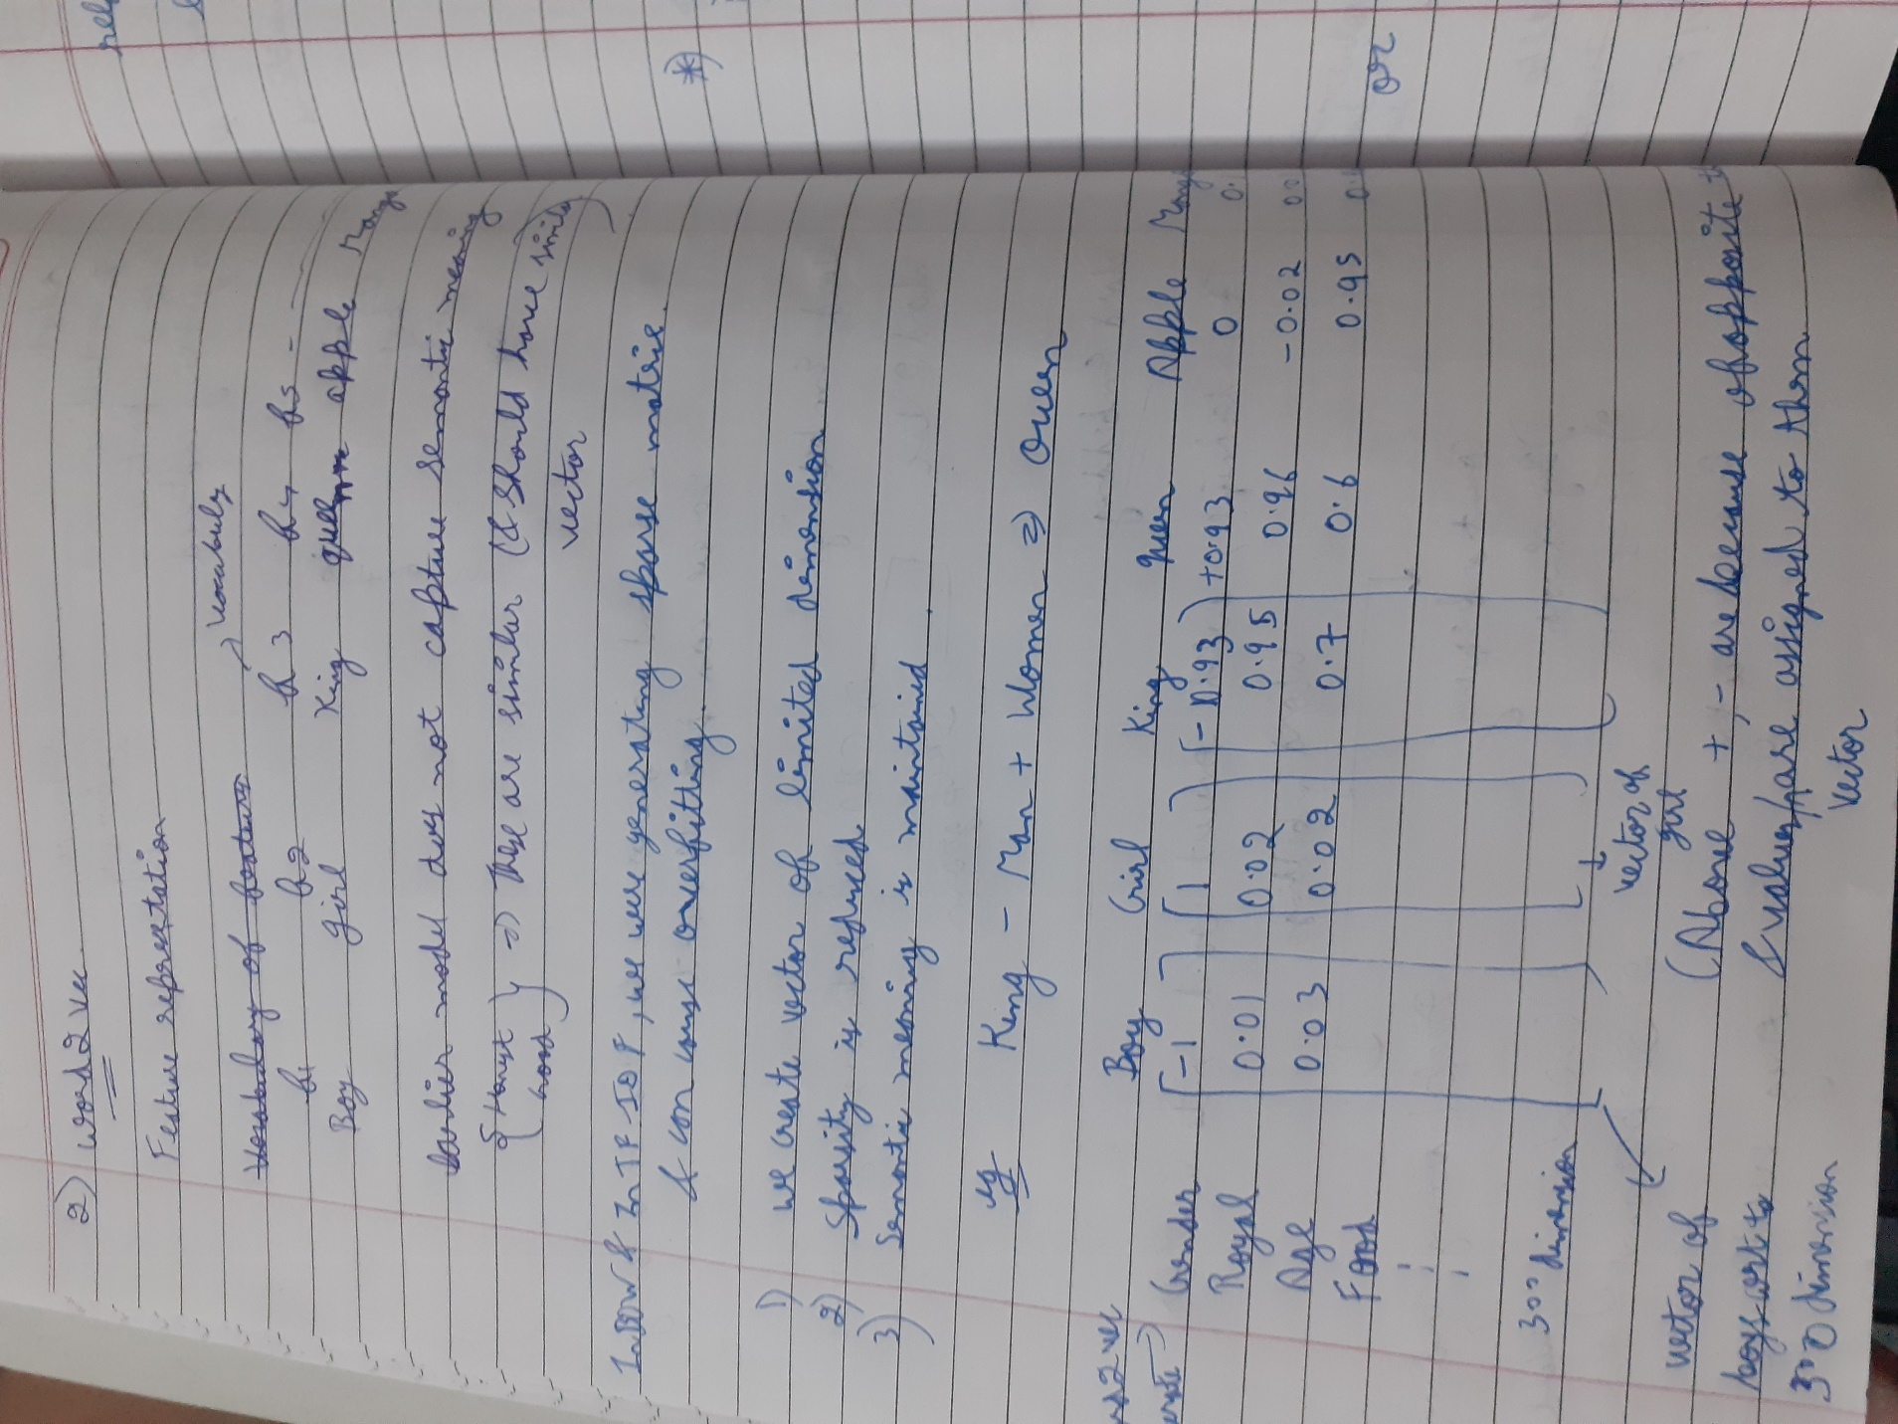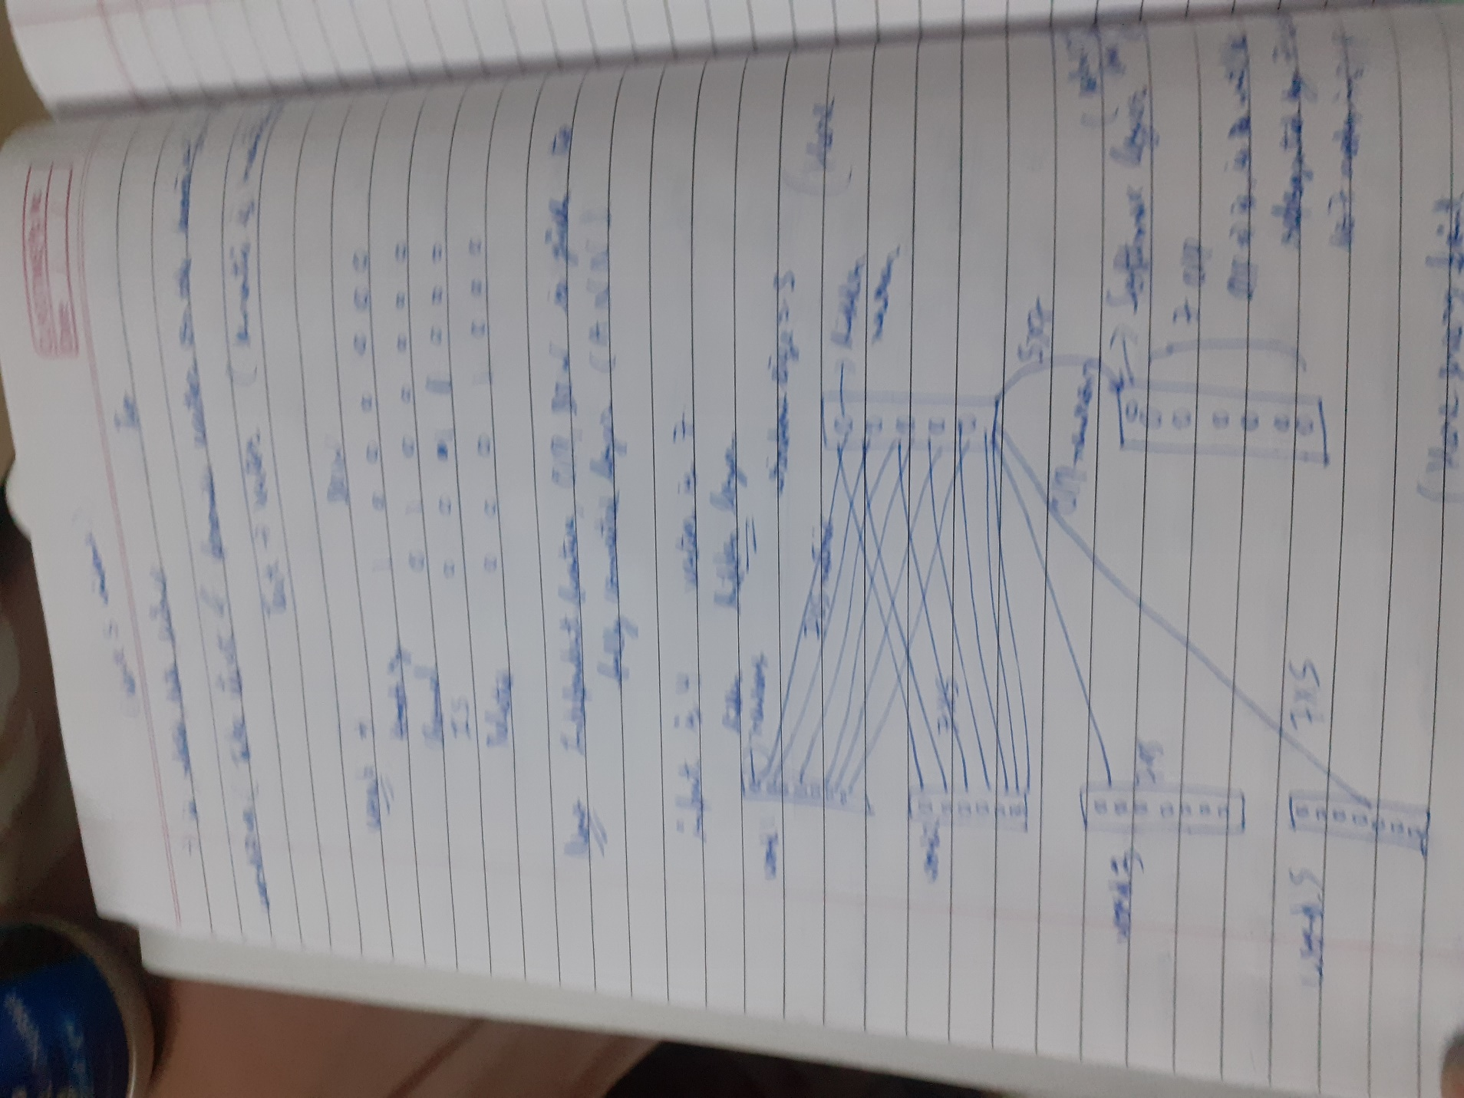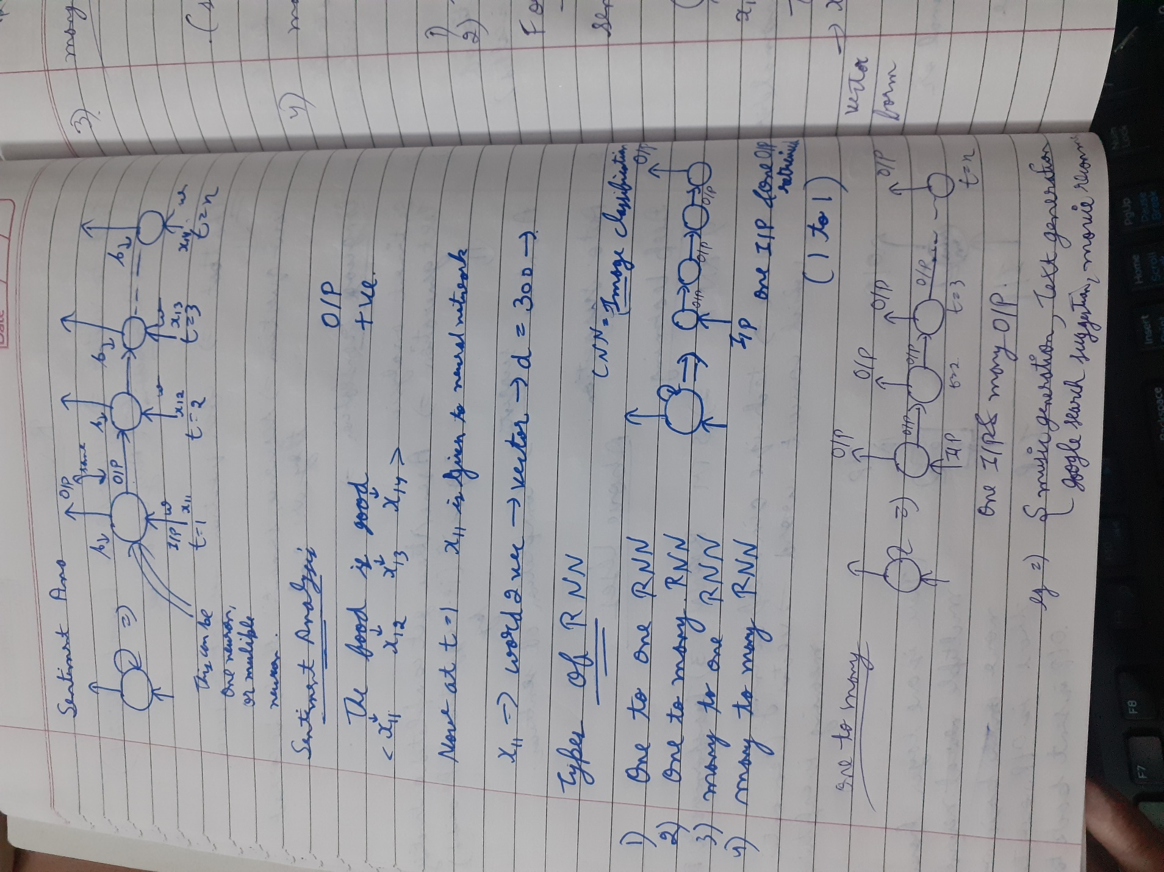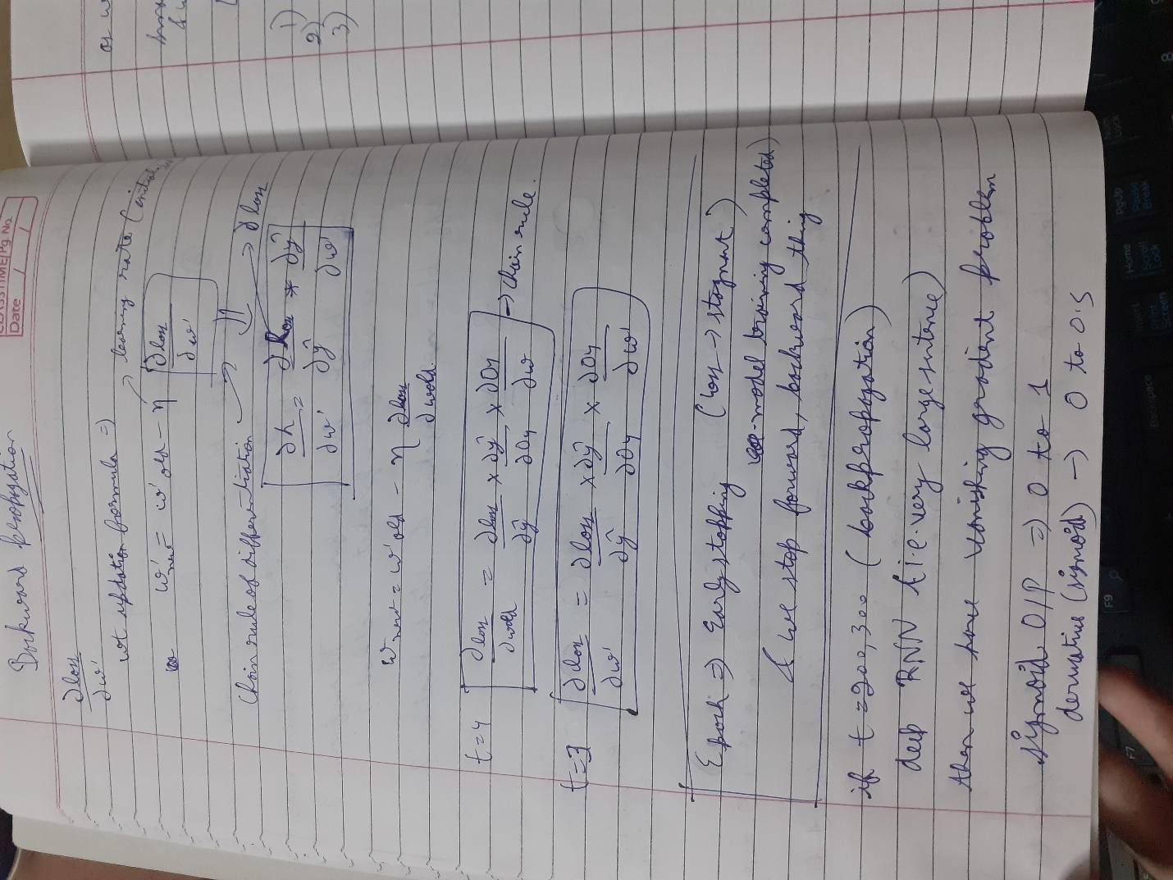 is implemented on random small data and also, today I started with some EDA on the basic chatbot data of greetings and goodbye.

**Is Progress As per Track?**

Yes, I started with EDA today and learnt concepts of NLP to great level that will be useful once dataset get completed.

**Issues Faced Today:** (None)

**Issues Closed Today:** (None)

**Highlights:**

Today, I learnt NLP (RNN, word2vec, avg word2vec, LSTM RNN)

And started with EDA

**Concluding the day:**

So today, I learnt new concepts of deep learning and machine learning i.e. RNN, word2vec and LSTM-RNN. Also, started with EDA.